* **Create the two containers with single pod by using kops:**
* First create the ec2 instance in ubuntu in t2 medium.
* Change the server into root,update the server.
* 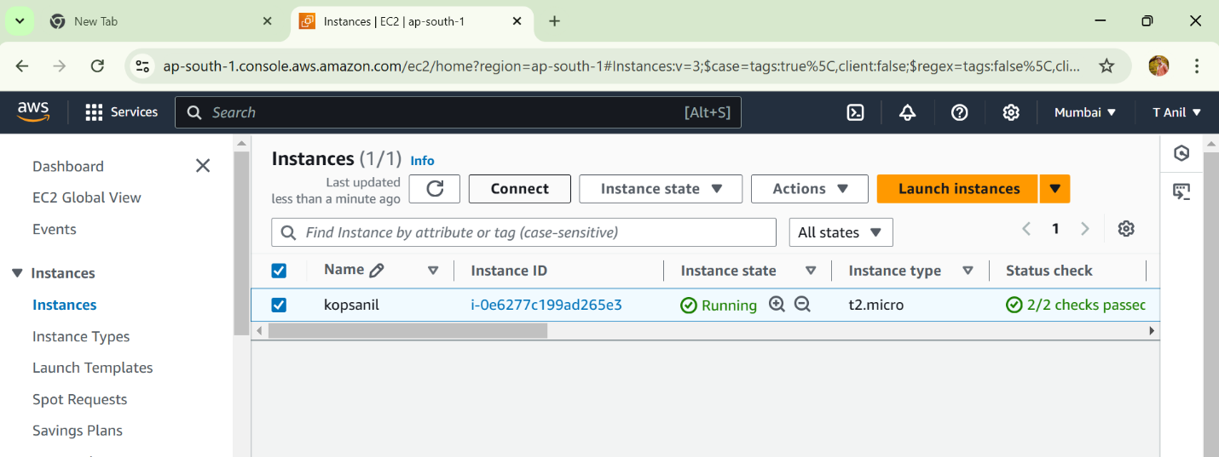
* Install the docker and kubectl
* Give the execute permissions to kubectl file using command **chmod +x kubectl**
* move the kubectl file by using **mv kubectl /usr/local/bin** command. 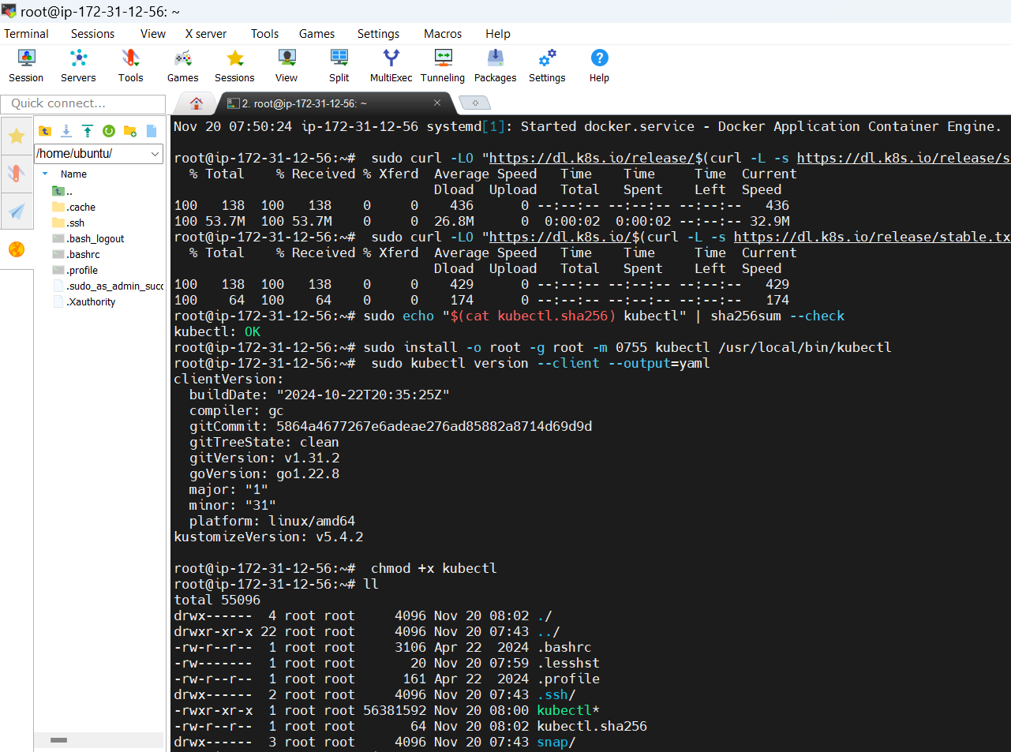
* Create the IAM user and add the administrator policies to that user.
* Configure the AWS CLI by using **aws configure** command.
* Now give the access key and secret key and region and format in json.
* Install the kops by using below command

**curl -Lo kops https://github.com/kubernetes/kops/releases/download/$(curl -s https://api.github.com/repos/kubernetes/kops/releases/latest | grep tag_name | cut -d '"' -f 4)/kops-linux-amd64**

* Give the execute permissions to this kops file. 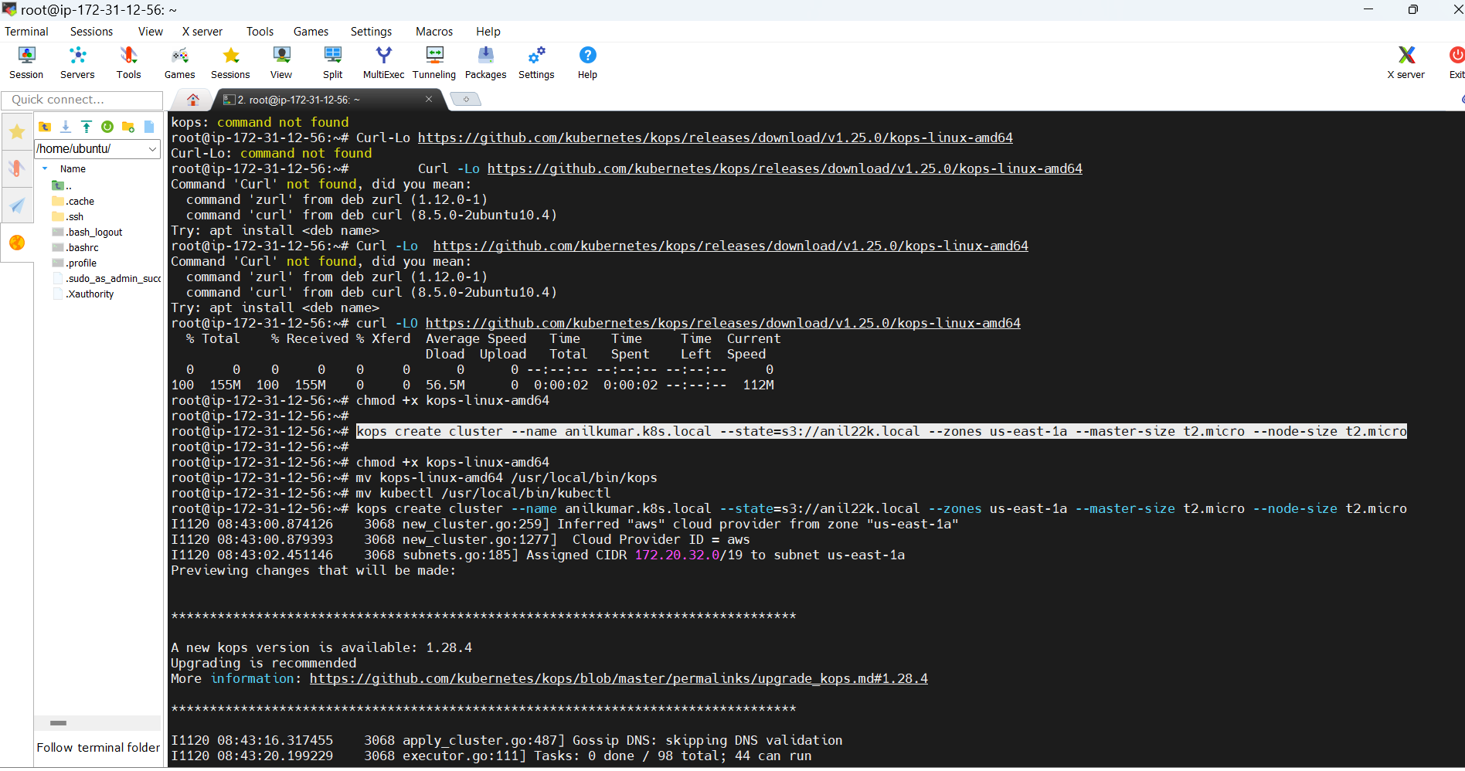
* Move the file to /usr/local/bin by using **mv kops /usr/local/bin** command.
* Open the .bashrc file export the path by using **export PATH=$PATH:/usr/local/bin** command.
* 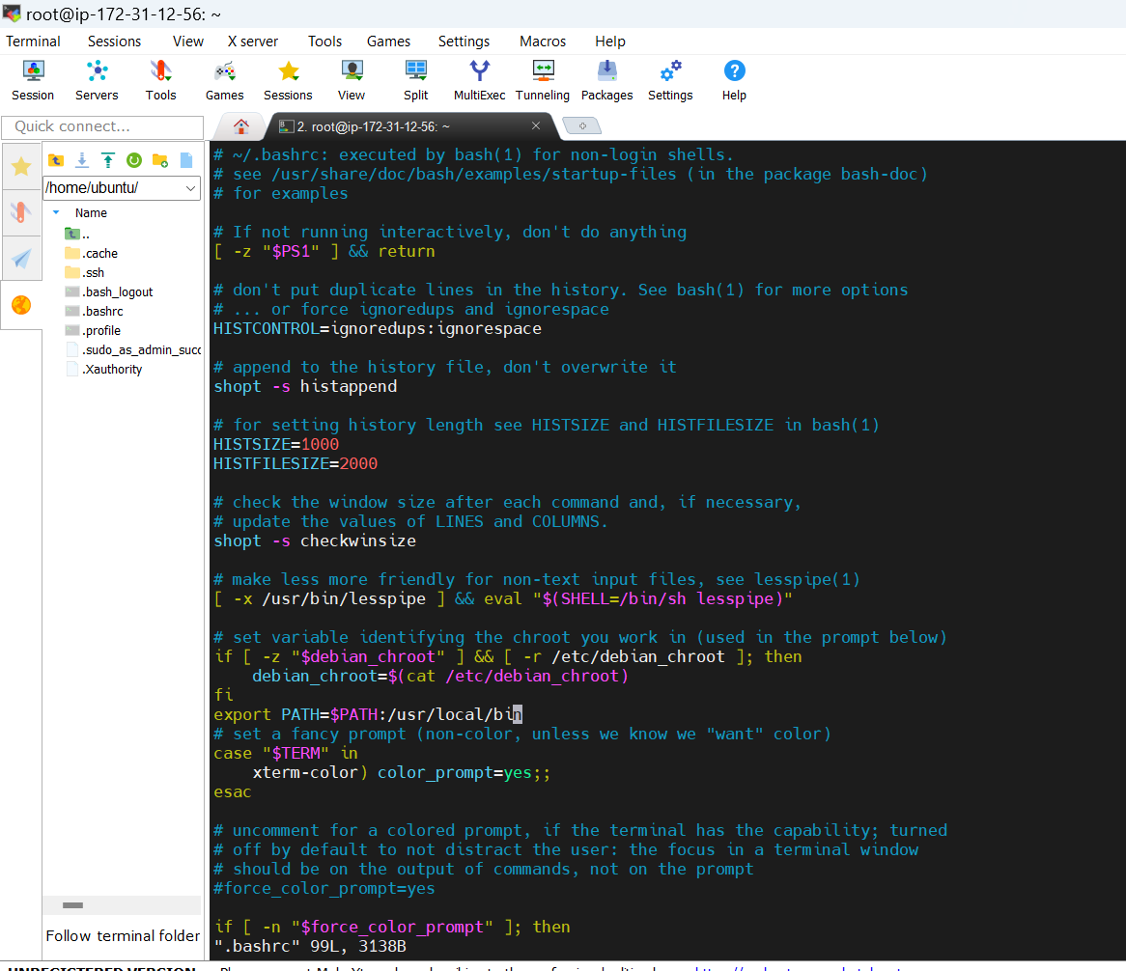
* Execute the .bashrc by using **source .bashrc** command
* Create the s3 bucket by using below command

**aws s3api create-bucket --bucket bucketname --region us-east-1**

* Files inside the s3 bucket.

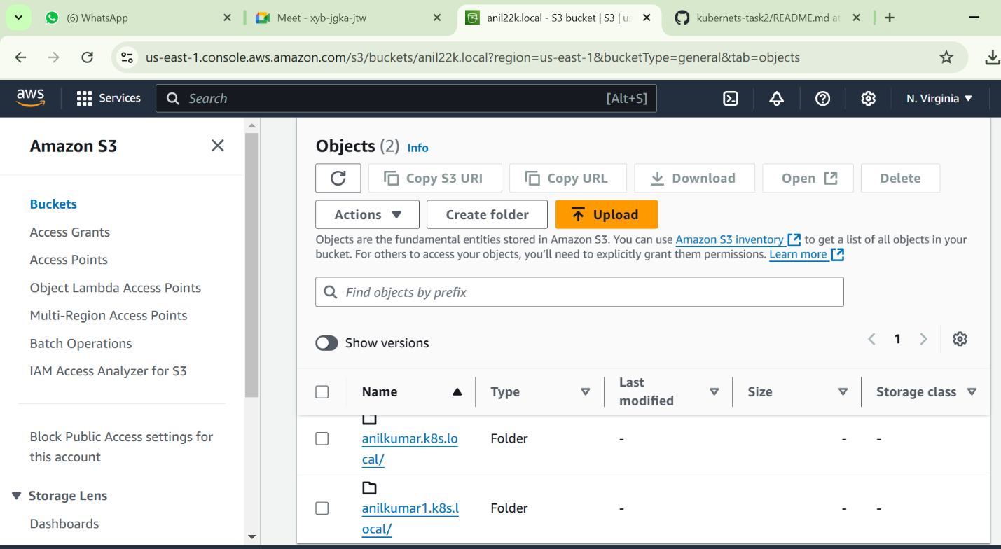

* Enable the s3 versioning

**aws s3api put-bucket-versioning --bucket bucketname --versioning-configuration Status=Enabled**

* Export the s3 by using command

**export kops_state_store=s3://kopsbucket**

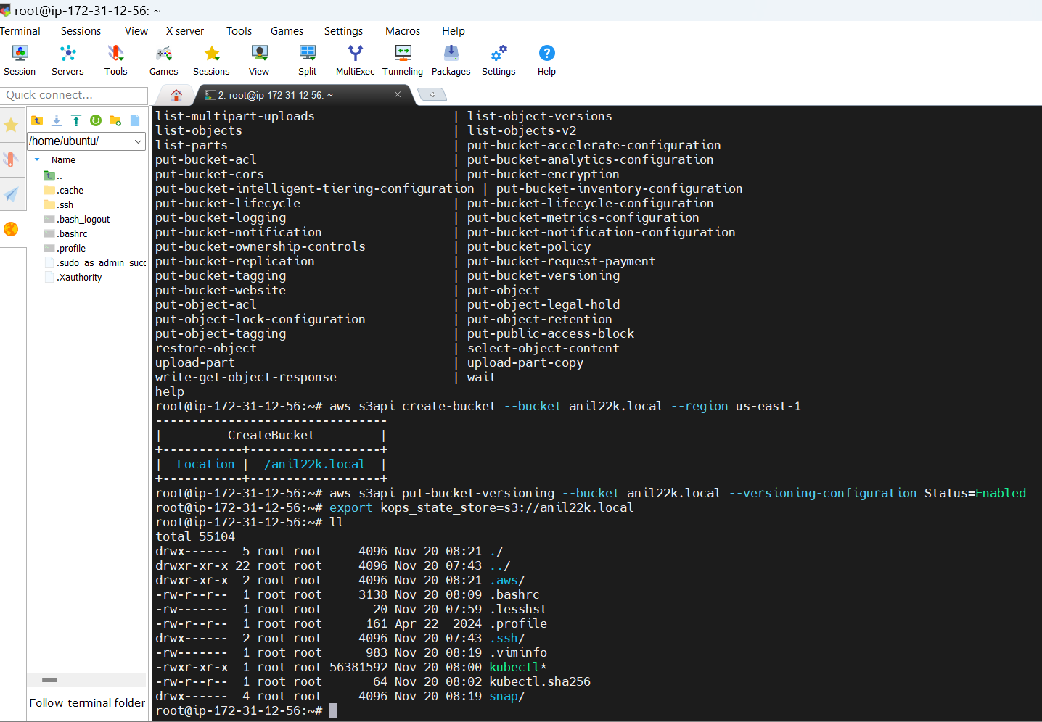

* Create the cluster by using below command
* **kops create cluster --name name of the cluster --state=s3://bucketname --zones us-east-1a --master-size t2.medium --node-size t2.micro**
* update the kops by using below command
* 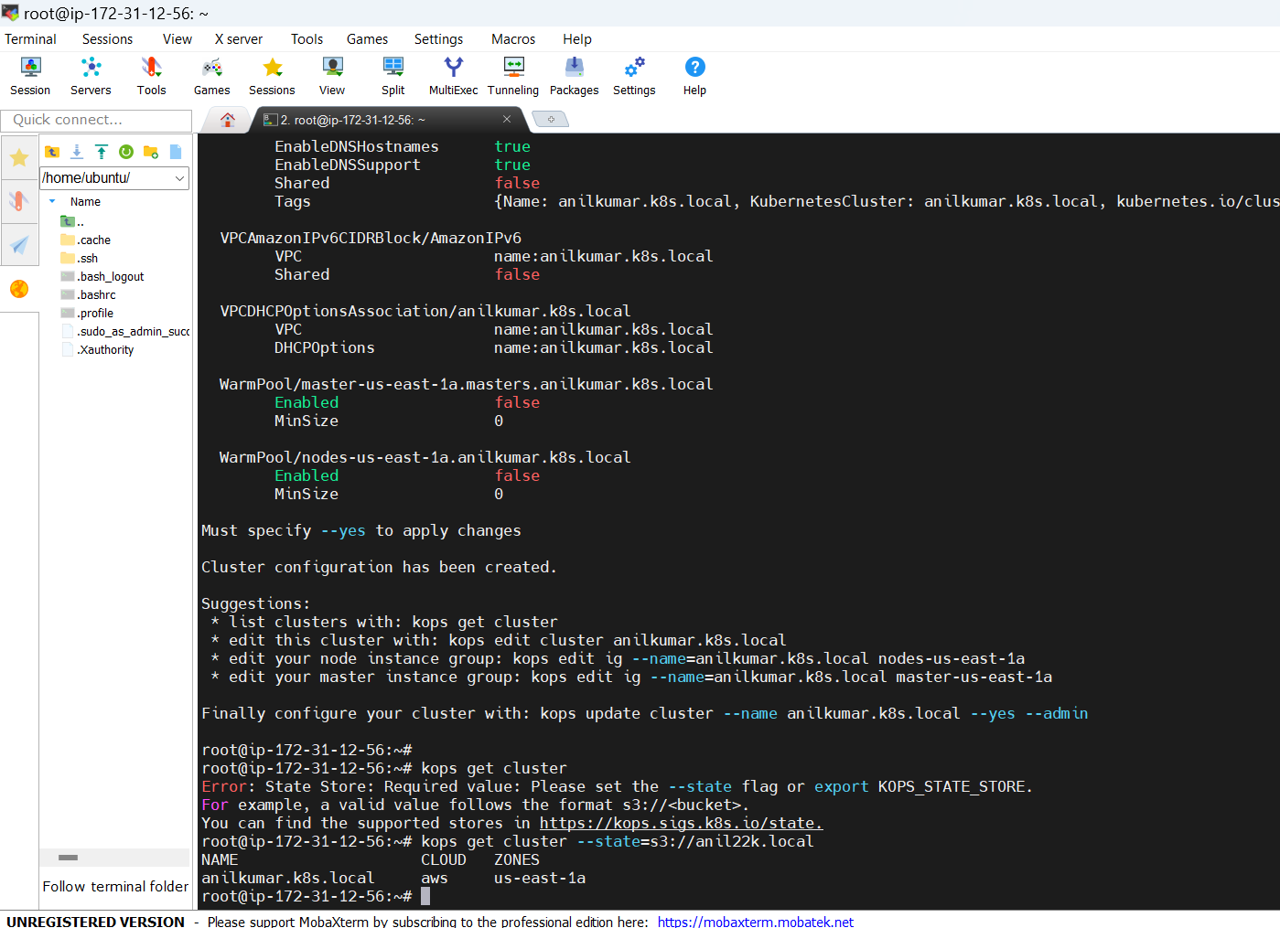

**kops update cluster --name clustername --yes --admin --state=s3://bucketname** 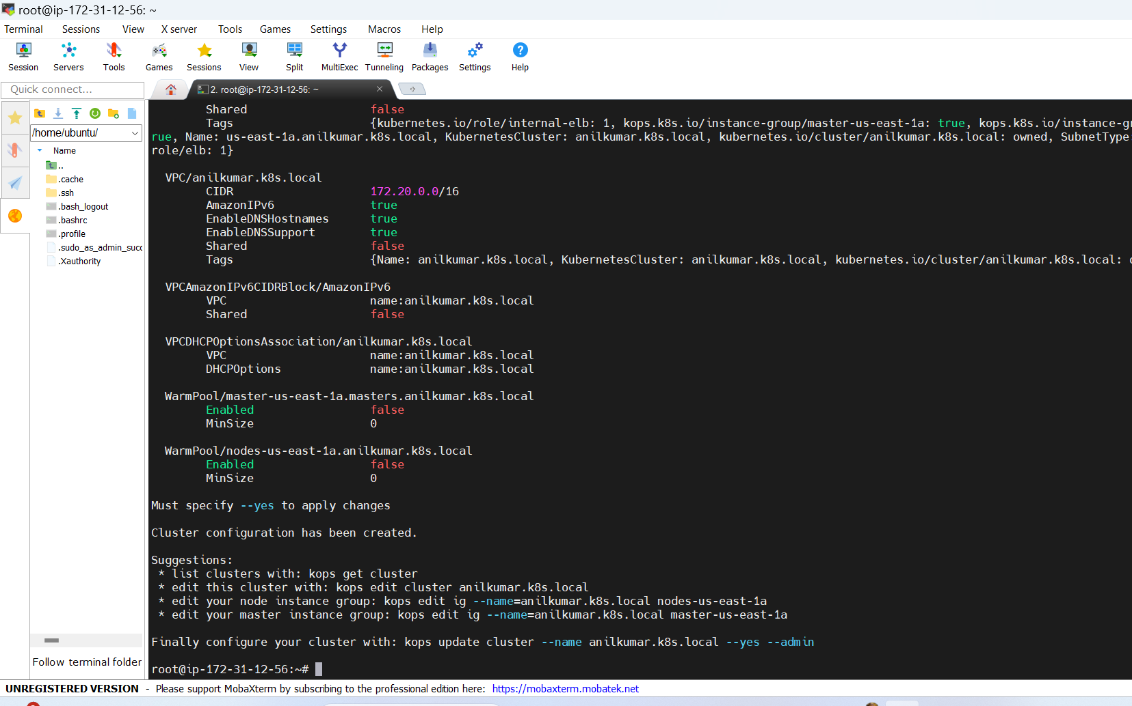

* **kops will automatically create the instances and load balancer and autoscaling group.**
* 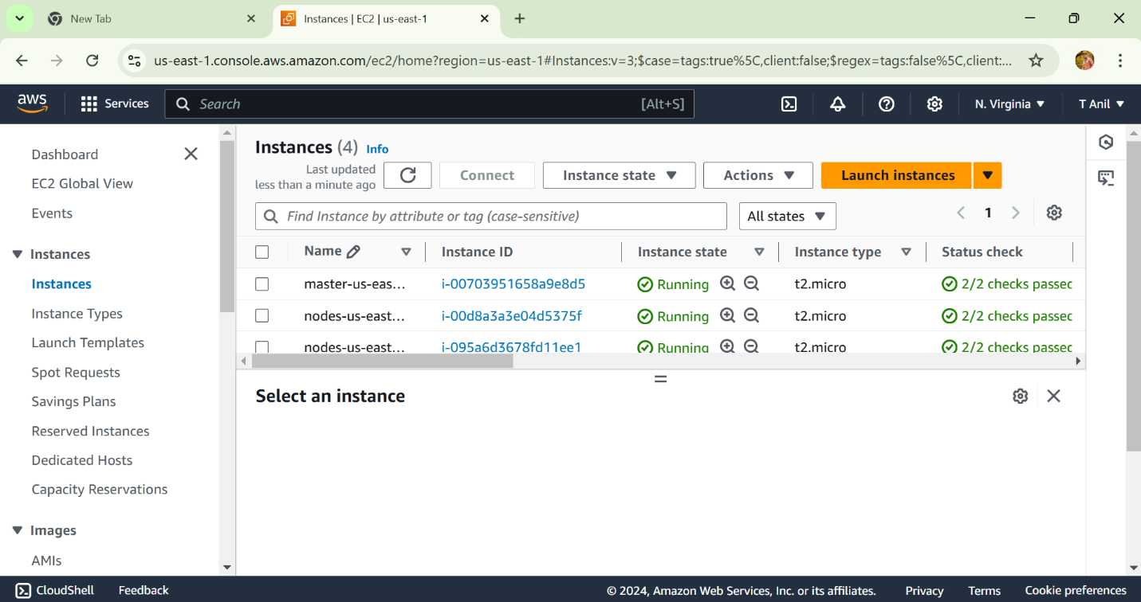
* **Automatically create the autoscaling**

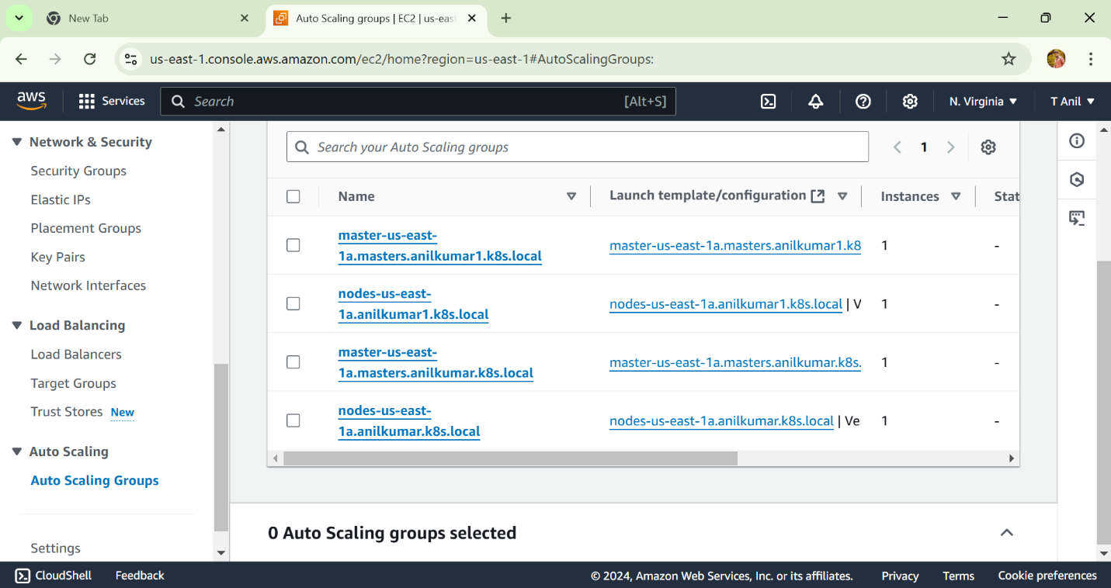

* **Load balancer**

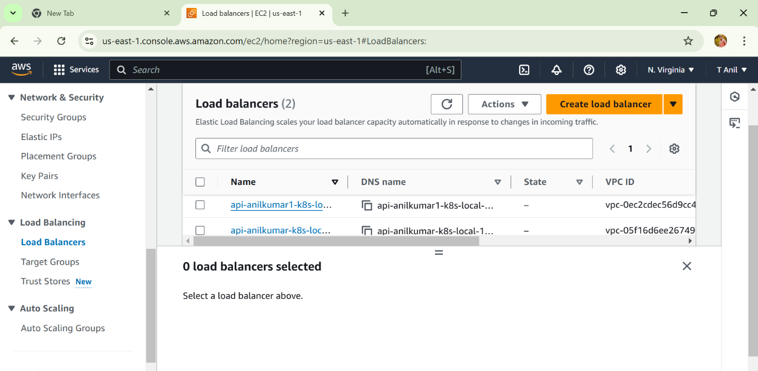

* Write the yaml file by using **vi filename.yml** command
* create the pod with two containers.
* 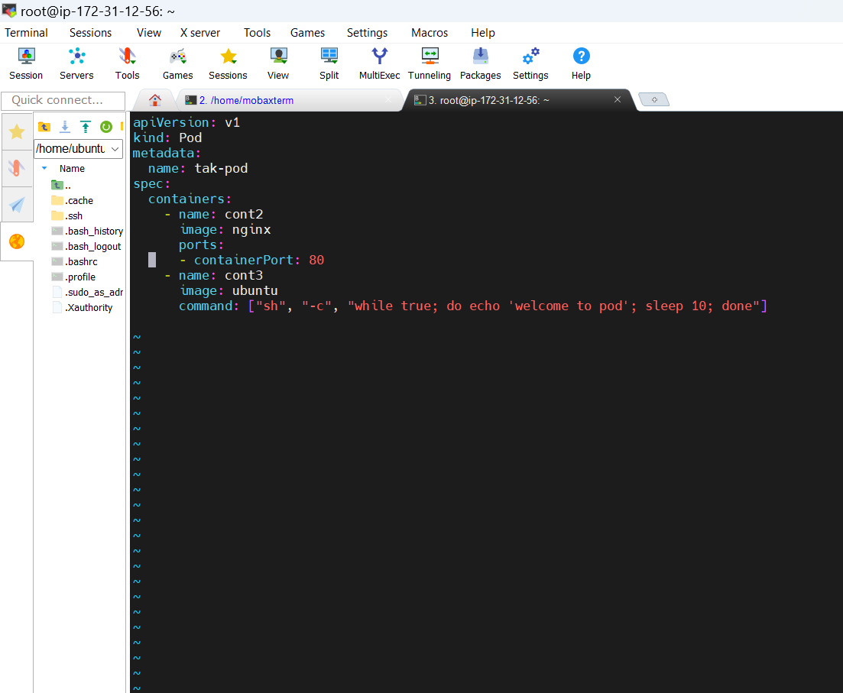
* **Two containers are creating**
* 